

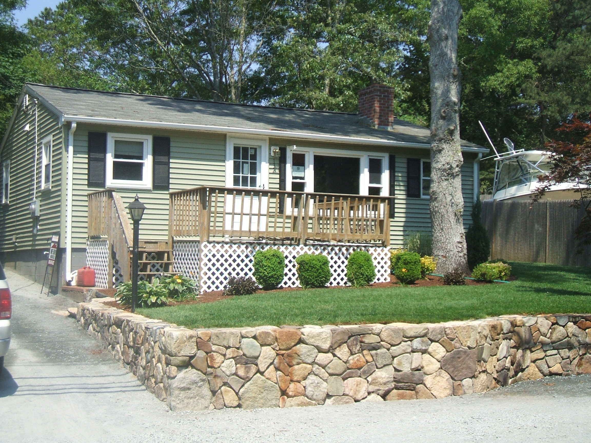

ASKING $185,000
This Totally Renovated 2+ Bedroom home is waiting for a new homeowner. Move in and drop your boxes on the floor and unpack. Your new home has it all, hardwood floors, an all new kitchen including; new oak cabinets, new counter tops and all new appliances. Your home has a brand new bath, brand new 3-bedroom septic installed just days ago. Your new home has mature landscaping with a beautiful handmade stone wall and a new driveway. You Home has all new electric wiring, new windows, siding and roof. Your home is listed under Assessed Value. Come by to our Open House we are not showing it until then.
508-847-0327

OPEN HOUSE on July 12th & 13th 2008

Property Details
Style Ranch
Stories 1 Story
Exterior Wall Siding
Roof Structure Gable/Hip
Roof Cover Asphalt Shingles
Heat Fuel Electric
Heat Type Electric
AC Type None
Total Rooms 5 (2 Beds, Kitchen, Bath & Office)
Bedrooms 2 Bedrooms
Basement Crawl Space
Living Area 768 square feet
Year Built 1960
Lot Size Approx Acres: 0.14 (6,000 sq. ft.)
Taxes $1,353.02 (2008)
Assessed $194,400
Foundation 32 x 24
Map / Lot 122 / 182
Lead Paint Unknown
Property Updates
- Hardwood Floors
- ALL New Bathroom
- ALL New Kitchen
- Brand New Appliances
- New 3 Bedroom Septic
- Custom Stone Wall
- New Siding
- New Windows
- Updated Electric Circuits
- Fire Place

For more details and additional pictures check out our web site listed below.

Contact US
- OFFICE: (508) 759-0868
- CELL: (508) 847-0327
- WEB: www.BuyKingHomes.com
- EMAIL: Shayne@BuyKingHomes.com
Recent Sales from the AREA
- 172 Swifts Beach Rd Wareham – Sold for $237,000 - 2/27/08
- 49 Shore Ave Wareham, MA –Sold for $196,000 – 1/9/08
- 25 Vernal St Wareham, MA – Sold for $190,000 – 4/30/08
- 120 Park Ave Wareham, MA – Sold for 182,000 – 3/28/08

